TRIAGE, TRAINING & SUPPORT

FOR PARENTS REQUESTING ADOPTION SUPPORT

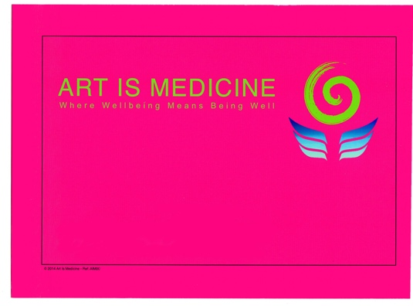

GROUP PROPOSAL

COURSE DESIGNER

ANNIE LLOYD

THE PHOENIX CENTRE
@

THE TURNING POINT
SHERINGWOOD
BEESTON REGIS
NORFOLK
NR26 8TS

CONTENTS

- Title page
- Contents
- Description of the group
6. Description of the venue
7. The facilitators & presenters
8. Primary aims of the group
9. Start date – How the day will be divided – Number of participants – Families’ Times – Length – Cost
10. Notes
11. Overall theory and approach of the group
12. The recipe for a successful journey through child development
14. Further information
16. The future
17. Appendices

DESCRIPTION OF THE GROUP

This group has been specifically and uniquely crafted to address the increasing numbers of adoptive parents requesting support with the challenges that they are experiencing with their adopted children as a family.

It will provide at its core -
- Stress Management in various different forms in order that each participants needs are met.
- Skills Training from proven effective modern techniques including a synthesis of:
MINDFULNESS,
HAKOMI BODY-CENTRED PSYCHOTHERAPY,
EMDR,
ART IS MEDICINE,
KUBLER-ROSS GRIEF COUNSELLING,
KINESIOLOGY,
CBT,
TRAUMA AND SYSTEMS THERAPIES
TRANSPERSONAL CREATIVE IMAGINATION WORK

- Psycho education of the above therapies. Additionally, following and replicating the developmental model and, within the context and container of Mindfulness and Hakomi principles, the advances of neuro science will be explained in an accessible form i.e. how the different “brains” work within children and babies as opposed to adults. Participants will have space to apply this information to their individual children and experiences.
- Psycho social support for both parents and children.
- The opportunity which arises for those professionals presenting and social workers to assess the different needs for support in turn supports others to both prioritise and allocate appropriate further therapy as necessary.

Having completed the course, it is anticipated that participants will have created their own support group which can then continue and benefit from further input both from the primary facilitator on a 3 monthly basis as a form of supervision and for participants to select further input from the broader range of available service providers. (* see appendix 5 As a model the group then becomes a piece of heuristic research which can be quantified.)

It is hoped that by completing this course, it may reduce the need for further support in some cases.

This course will also provide training and support beyond that which CAMHS currently offers and as such, would become a resource for CAMHS who itself, is under huge pressure and suffering from being under resourced to meet its current demands.

Primarily this course addresses the challenges of the developmental trauma so many LAC and adopted children have experienced, and the profound impact this can have on parents as a result of intra psychic interlocking. Achieving this lowers the risk of adoption breakdown.

- It offers opportunities for identifying stress patterns in both parents themselves and their children. Through learning ways to begin the process of managing the stress both of individuals and the family as a whole, greater attunement becomes possible. Prevention rather recovery lowers the likelihood of secondary trauma.
- Learning how to resource themselves and their adult relationships lowers the all too frequent strain parenting puts on marriages.
- Skills training allows parents to have a positive impact on the behaviour of their dysregulated children and develop their parenting skills.
- The group aims to provide parents with a place where they no longer feel isolated and alone.
- It will provide information, guidance and signposting to relevant support services as a consequence of the presence of a specialist social worker.
- The provision of some degree of group therapy allows an ongoing support group to emerge which will offer both psychosocial support and the resource of regular further training of participants’ own choosing.

- Many parents have done extensive research on the challenges their children face which the whole group can benefit from. By doing this, authentic group wisdom can develop which in time can be shared with other groups who have completed the course.
- As the wider network of support from groups who have completed the course strengthens, this reinforces the presence of a healthy system in place around children whose early experiences have been of living within a damaged and distorted, unhealthy system. This has the potential to act as a tuning fork restoring and attuning the child to what nature intended.

DESCRIPTION OF THE VENUE

The Phoenix Centre is a new, purpose built, therapy centre situated within the four and a half acre grounds of The Turning Point (which itself has been a therapy centre for over 14 years.)
It is an architect designed, timber framed, eco friendly and very light building overlooking the North Norfolk Coast. It has excellent facilities and can accommodate up to 30 people seated.

The whole area has been developed to be the home for Art is Medicine – a place where visitors feel safe, welcome and resourced by the creative, therapeutic installations with which they can interact. It offers sanctuary for families who have experienced trauma and provides the necessary requisites for them to regain the receptivity to benefit from what is on offer with the course.

See www.artismedicine.co.uk

FACILITATORS AND PRESENTERS

Annie Lloyd *

Mark Brayne *

Suzanne Lakin *

Denise Blackburn *

Proposed/requested Attending Social worker:
Carl Smith

( *Please see appendices 1- 4 for details )

PRIMARY AIMS OF THE GROUP

- To provide some immediate triage.

- To prevent adoption breakdown

- To help parents significantly reduce the impact of their childrens’ dysregulated behaviour by developing their parenting skills and strengthening their ability to identify; contain and lower sympathetic arousal.

- Provide parents with a place where they no longer feel isolated, marginalised and alone; feel listened to; and can normalise their experiences within a group context.

- To gather information, guidance and signposting for relevant support services.

- To provide some degree of group therapy out of which emerges an ongoing support group which will benefit from both that psychosocial support and the resource of regular further training of their choosing.

- To provide a safe container in which to learn.

START DATE - HOW THE DAY WILL BE DIVIDED – PARTICIPANTS, FAMILIES, TIMES AND LENGTH

(N.B. These are suggestions and are open to amendment.)

PROPOSED STARTING DATE – OCTOBER 2016
Six days with parents and one or two days with entire family.
Total: 7/8 weeks.

The course will run from 10:00 – 4:00 on the same day each week (provisionally Wednesday.)

The final day(s) will allow facilitators to offer family activities from their therapeutic styles and be able to evaluate the group dynamics of each family.

Maximum number of participants - 12.

A minimum of 2 facilitators present for each day, but it is anticipated that all 5 (i.e. including Carl Smith) will attend the first day and hopefully the final day as well. (This will need to be added to the costing if approval is given.)

Lunch and refreshments will be provided.

Technical and administrative staff will be available on each day of the course.

Total package of course provision including venue, staff, refreshments and facilitators can be found in appendix 5. This does not include report writing.

There will be ongoing assessment and should reports be required, separate costings for these can be found in app.5 and will need to be added.

NOTES

This is a basic outline of the group, its content, facilitators and location only in order to ascertain whether there is support for it being sent for funding approval. Further specific course content development will be provided should the proposal be considered valuable, relevant and therefore presented for approval to the Government Adoption Support Fund by Norfolk Children’s Services.

A considerable amount of time has already been invested in this proposal to date. This, as yet, has not been integrated into the costing but amounts to 7 hours interviewing time and 28 hours on course development.

Suffice to say that the presenters and facilitators are extremely experienced and have a huge amount to offer.

OVERALL THEORY AND APPROACH OF THE GROUP

The basic premise for this approach is that studying and then replicating the recipe for a healthy child to emerge from the developmental journey.
By applying it to supporting the child who has failed to make it as a result of early trauma and poor attachment, the opportunity is created for that child’s system to heal and begin the process of recovery made possible by the presence of therapeutic parents.
The brain’s relationship with the body can be reprogrammed to take advantage of its neuroplasticity.
The impact of those “missing experiences” resulted in the profound loss of family and that child, therefore, has been denied the somatic subconscious, innate knowledge of belonging that goes along with remaining within the system of birth parents, extended family and social group.
A deep seated grief ensued and this too fractured the developmental path at its earliest stages as a result of being taken into Care.

This is the price paid as result of the State’s intervention for that child’s survival.

Abandonment issues are woven into the earliest of experiences. It important to accept that this is utterly alien to the infant who has experienced a “good enough” developmental journey which has then resulted in healthy attachment.
So often adoptive parents experience further alienation as they know that other parents, in their attempts to empathise by pointing to their birth child’s apparently similar behaviour, cannot appreciate the challenges they and their children face.

It is hoped that one outcome of the group will be to promote greater understanding of this significant consequence and for it to become normalised.

Healthy attachment allows for a sense of self to emerge, which in turn then leads to good separation and autonomy and a desire to both individuate and express personal uniqueness whilst remaining a part of the group.

So what is that recipe for a healthy child to emerge from the developmental journey?

To have an innate felt sense of belonging to the tribe and part of the world.

To feel physically safe and welcome.

To have needs being met in a manner which allows the brain to develop properly and consequently, ”direct” the body effectively through the natural transitions of life.

Nutrition, warmth, mirroring, stimulus: socially, linguistically, opportunity for physical expression and to remain safely connected to curiosity and learning through play.

To have the expression of personal experience validated sufficiently to be able to grow beyond the inherent powerlessness of “acting out”.

To know and trust the adults around them.

To have the opportunity to interact with other children

For it to be safe to learn; explore and acquire a sense of self and self worth - including scope to explore freely what it is to be a girl/boy, and ultimately a man or woman and belong within society.

To know at a somatic level that, as a child, he/she has survived and can believe that there is an opportunity to thrive now.

To appreciate and feel gratitude.

This last point is a core element of the limbic system which connects on to the more human areas of the brain and far more important than is currently accepted. Seemingly innocuous it is a force strong enough to counter primal demands and distortions. It also demonstrates that a sense time is understood. Past is past and the present is sufficient for the future to be one to be looked forward to. The reptilian mind has no concept of time so it no longer is control of the child’s reality.

With these ingredients, a genuine opportunity emerges for a child to choose to trust Life to support them and their needs sufficiently for them to want to contribute to their community as adults and not as infantalised dependants.

Un-met needs exacerbate feelings of abandonment and lay down significant detrimental “core beliefs” that are then not just physical impressions but also neural pathways of “normality” that require rewiring neurologically.

As this is achieved and the “NOW!” nature of trauma is replaced with body-centred Mindfulness of what is there now in the present moment, the opportunity to make better choices is revealed. However, it is vital for those better choices, as they are made, for them to be reinforced consciously with repetition in order for them to be integrated into the autonomic system which makes habitual what is being repeated.

This group focuses fundamentally around supporting parents to acquire the requisites which allow them to do the job they have chosen, and support them against sustaining further secondary trauma.

The personal life experiences of the parents are relevant and may be affecting how they meet the needs of their children. Not having had them met themselves then, and/or unresolved grief, can interfere with their ability to do this too. Bringing this to consciousness and then being able to express them and have them accepted by the group begins the process of resolving them.

FURTHER INFORMATION

Every infant/child needs to have experienced: safety, welcome and protection;
and have had his/her needs met and then mirrored back to them by the people upon whom their survival depends. Those needs are for warmth, food, stimulus, social interaction and to belong at a somatic level. The sounds familiar to the baby’s in utero experience need to be regained after birth and translated into the smell and taste of mother.

As the brain is not fully activated until long after infancy, it is unable to differentiate one sense from another which means that the baby’s experience is synesthetic and he/she is unable to distinguish between self and other. Hence if one baby cries, any other baby within that proximity shares the same experience and cries too.

Therefore, if mother is unsafe, unsupported and toxified then her baby is too.

Research into epigenetics shows us that trauma experienced by that child’s father is passed along to the baby genetically through the sperm.
The degree of vulnerability a baby has to survive is primal. If the limbic system of both parents is compromised, it is inevitable that that is transferred into the next generation.

Long before the brain is programmed, activated and access is built to the hippocampus’ memory, profound impressions are made at a somatic level which affect how a child is programmed to relate to their world.

The one challenge of childhood is to survive.
To survive is the business of the amygdala – the reptilian brain. Fight/flight/freeze/avoid, if unresolved as a result of trauma show up in later life as psychological conditions such as aggressive and abusive behaviour, depression, dissociation, DID and attempts at suicide. (Self harming is now both an expression of distress when words will not do and an increasingly cultural behaviour particularly in adolescents.)

The limbic system i.e. the mammal brain, providing it gets its needs met, creates neural pathways in the brain on to the primate brain which, in turn activates the right brain, the pineal and creative imagination. It is also the region which allowed emotions to develop and the primal power of the amygdala can be reduced. Research shows us that threat to survival if experienced by a whole collective is unlikely to get stuck in trauma. The profound experience of solitary abandonment leads to significant complications for the developing brain which will be explored in the group.

Connecting across to the left brain where rational thought and processing occur, the autonomic system and the more sophisticated qualities of the prefrontal cerebral cortex engage to reduce the sense of abandonment.
Our evolution gives us the potential to understand the mathematics and science of Life as well as its order and beauty.
As a species we are still rapidly evolving.

When combined with the phenomenal capacity of a human baby to learn, (which means that the human baby is born approximately one year earlier than would be necessary to have any reasonable viability,) that wiring must get beyond the “protection” of the amygdala. The presence of the parent primate is crucial for this to occur. The meeting of the mother’s needs extends out to the quality of experience she has within the tribe. If the mother is unsafe, her baby accepts that truth from her that the world is unsafe and not to be trusted. Innocence becomes damaging vulnerability. The receptivity necessary for learning is denied and all dynamic action irrespective of its intention is interpreted as a threat to survival.

In the past, it was the indigenous brain which processed and made sense of what the body “knows” at a cellular/genetic level. Working in the natural surroundings of The Turning Point supports the process of making sense of who are and how we relate to the world because its whole ethos is in tune with how evolution has made us. The use of ritual, and the building of lasting creative constructions which act as an anchor and resource when participants return to their homes, completes the group experience.

When arousal of the sympathetic system is switched off and the parasympathetic system flushes adrenaline and cortisol away. This makes the anandamide rewards system accessible which creates joy and bliss.

In essence, we aim to help support the process of transforming the reptilian brain into a “dragon brain” in service to the wisdom of the body and which supports the process of individuation without risking loss of belonging. If it is a good enough path for evolution to have taken, it is worth studying and replicating.

THE FUTURE

Whilst this model has been developed primarily as a response to the increasing numbers of requests being made for Adoption Support, it is imagined that it can be adapted to serve others in the Caring Professions working with LAC and adopted children - i.e. CAMHS professionals, educators, the police and social workers.
It may also be of value in the treatment of PTSD more generally.

Appendices

.

- Annie Lloyd – Biography and picture.

- Mark Brayne – Short biography and picture.

- Susanne Lakin – Resume of qualifications and experience and picture.

- Denise Blackburn – C.V. and details of relevant experience.

Appendix 1.

ANNIE LLOYD

(A biography of qualifications and relevant experience.)

As a student at St. Gabriels College – London, I was the student representative on the academic board.

After gaining a B.Ed (hons.1st class), my first career was in secondary education as an English teacher. (Not one child failed to pass their English Language ‘O’ Levels throughout the time I taught this subject.)

Having had my two children, I returned to teaching in order to be able to gather relevant data and experience for my case histories whilst doing a post grad. Extended Certificate in Counselling for the Caring Professions at the Lincoln Clinic – (attached to the Tavistock Clinic, London.)
This meant that I returned to education to work with those pupils unlikely to gain any academic qualifications and so had little sense of hope or self worth. They were working towards a CSE in Family Concern and all passed with Grades 1 or 2. This were amazing young people. Their unit became a hub for impromptu, pupil support which resulted in the school becoming the first to get official funding from Hampshire County Council to provide proper counselling, and they left with a real sense of accomplishment.

At this time, the academic exam system was moving from O levels and CSE to the current GCSE. It was identified that this was causing significant stress to staff and pupils alike and a lunch time stress management club was started which was attended by people from by both those sectors of the school up to and including the deputy headmaster. We were able to include the science department to gather scientific data and this became the basis for my joining a Ph.D. level research group at Reading University where I presented my work.

With a clear interest in this area of research, I went on to study for my Diploma in Psychotherapy at the Centre for Counselling and Psychotherapy London at the same time as studying for a post grad. certificate in Hakomi Therapy. At CCPE I went on to do their Advanced as well as the Supervisor’s Training. (Again, this was one of the first formal trainings available at the time for supervisors.)
For 25 years I taught, trained, mentored to Masters level and supervised with overall responsibility for all student supervision for twenty-five years, as well as facilitating large groups.
I also gained a Teacher’s Certificate in Hakomi therapy, trauma therapy and couples work which enabled me to run workshops internationally.

I have taught Body-centred Mindfulness for over 30 years.

Some 20 years ago, I suffered very serious complications from surgery which nearly ended my life and there followed a significant period of recuperation during which time I studied Anthropological Sculpture Therapy and engaged in Equine Therapy. It was at this point that I created the Art Is Medicine project. (See www.artismedicine.co.uk.)

At that time most of its installations were in health centres and hospices.

My children are now adults with children of their own and becoming a grandmother with 24/7 involvement in their care for over 16 years has provided me with an extraordinary opportunity to observe and engage as a trusted attachment figure without the visceral responsibility of a parent. This and the nearly 10 years of working as part of the Adoption Support Team has allowed me to develop my own method of working with this very specialised group of society.

My son and his family lived for 7 years in Beijing PRC with their daughter. His wife and I started The Beijing Baby Academy which was designed along Art Is Medicine principles in order to address the considerable pressure on children, and their parents who had experienced more Western parenting styles, as a result of the One Child Policy and the traditional expectations of both teachers and grandparents.

Over a period of forty years, I have attended numerous CPD trainings in anything I have found useful to the development of my craft and have integrated many different approaches to trauma as well as Internal Family Systems methods & Bert Hellinger Family Constellations maps. For 6 years I was a core facilitator of a Women’s Ritual Group and assisted Marianne Woodman on a retreat in the Swiss Alps as well as running my own retreats with Coralie Mansfield an Anglican minister and founder member of the Art and Spirituality Movement.

Art Is Medicine has been consistently involved in the COASTARTS charity and this year I have been made Chairman. Our aim has been to make available many aspects of my work to local families and the community in general. COASTARTS works in close collaboration with Arts North Norfolk. Recently, this has included work with dementia sufferers and their carers.

www.annielloyd.co.uk

My favourite quote:

“Never doubt the ability of a few committed individuals to make a difference. Indeed, it is the only thing that ever does.” Margaret Meade – anthropologist.

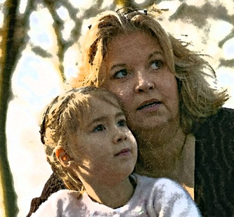

Appendix 2.

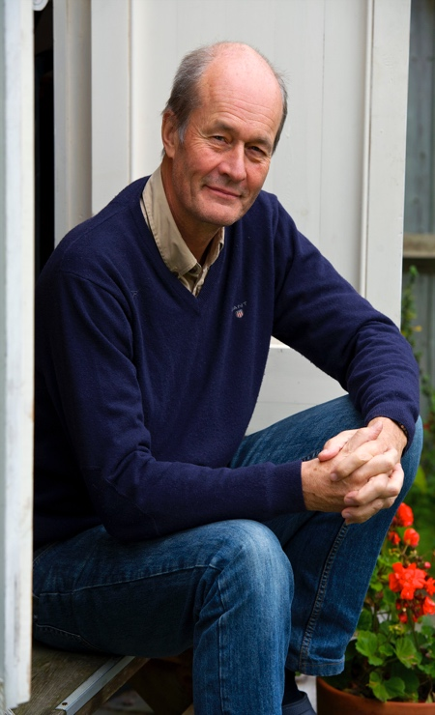
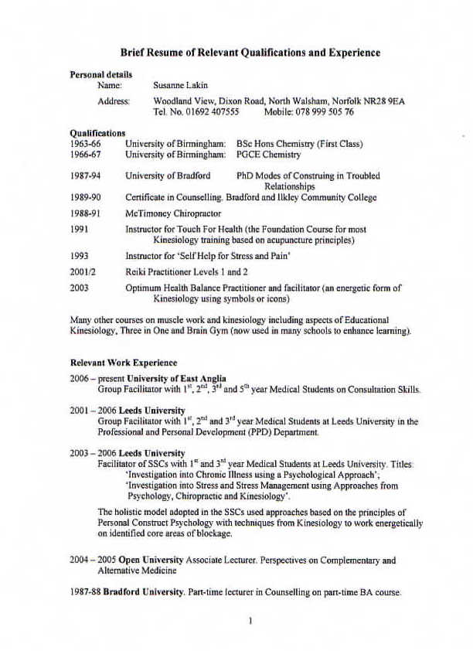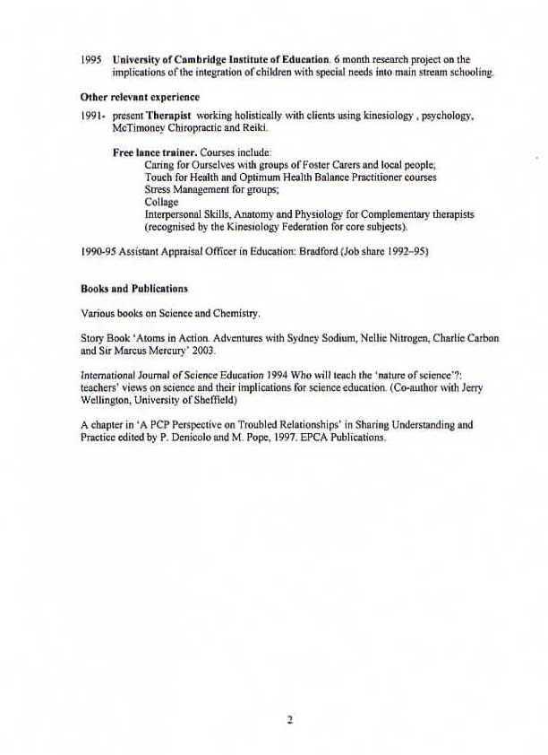
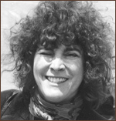
Susanne Lakin
